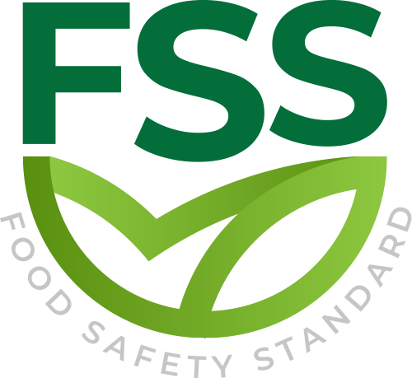

REQUIREMENT ACCREDITATION BODIES STANDARD

Document Code _ FSS-STD-003
Approval Date : 20.02.2020

Title: Food Safety Standard (FSS)
Contact Adress : Merkez Mahallesi Dr Sadık Ahmet Cd, No 38/44 A Bağcılar/İstanbul – Türkiye / Turkey
Contact Mail: info@foodcertificate.org
Website: www.foodcertificate.org
Phone: +90 212 702 40 00

ABOUT US
The Food Safety System (FSS) certification program developed by our organization is a system for the inspection and evaluation of food safety and quality according to accepted standards. The certification program in question not only ensures food safety, but also undertakes responsibilities such as public health and environmental protection. This certification program is recognized as the most important initiative of recent years for a more effective and quality food management.

While developing the Food Safety System (FSS) certification program, our organization followed a global food safety strategy and adopted a safer food policy to be healthier. According to this strategy, preventing foodborne diseases and ensuring food safety require holistic, risk-based and timely food safety policies and strategies.

Our organization continuously improves its effectiveness by participating in the efforts for the development and implementation of the food management system in enterprises. It supports businesses in the food industry to meet legal and regulatory requirements, tries to establish a quality policy in businesses, supports businesses in establishing food safety targets, directs management reviews and tries to ensure the correct and effective availability of resources. In all these works, our organization approaches businesses in an impartial and independent manner and does not enter into any conflict of interest.

Our organization acts with a sense of responsibility in order to be with people who care about their nutrition and to help them make safe food choices. In this context, it provides Food Safety System (FSS) certification services to support companies that produce, store, distribute and prepare food in order to prove their efforts in this direction.

- SCOPE
This section specifies the requirements upon which the foundation accepts certification bodies that provide certification services to licensed certification bodies.
A.1 Responsibility
- AB should designate a primary and secondary contact to communicate with the foundation.
- AB shall promptly notify any changes in the contact of the foundation, its ownership, legal status or any other issues related to the accreditation.
- At least one AB contact or assessor should attend the annual coordination meeting.
- The communication and other related information about plan requirements changes shared with AB through webinars and technical communications should be shared by AB and all assessors of the plan, and records of such training should be kept.
- If the certification status of the CB changes, AB should notify the foundation immediately.
- Upon request, AB shall cooperate with the foundation to process information requests related to the performance of the CB approved by it.

- ACCREDITATION
- AB shall verify that the CB has signed a (temporary) license agreement with the foundation to certify the pre-defined ISO 22003 food chain subcategory (or category, if there is no subcategory) and/or FSS quality specified in FSS-STD-002.
- AB is not allowed to issue recognition certificates for category or subcategory licenses to the foundation, which includes the extension of the scope of the new subcategory
- The accreditation process should cover all scheme requirements applicable to the accreditation scope.
- AB shall issue confirmation of rejection of the accreditation application to the applicant CB, including the detailed scope.
- AB should issue to the CB applicant a confirmation application for accreditation including the detailed scope.
- The scope of accreditation should be clearly defined and used as a part of the accreditation certificate defined below, and this part is summarized in FSS-STD-002:
- FSS – Food Safety Standard
- FSS Quality
- ISO 22000

- WITNES AUDIT - PROGRAM
Witness audits must meet the requirements of witness activities recognized by the management system certification body, such as the following specific requirements of the FSS plan:
- The initial and scope extension assessment should at least require one (1) FSS witness audit for each category detailed in the temporary or complete CB license agreement;
- AB shall conduct an FSS witness audit covering all categories within the scope of CB certification during the AB certification cycle.
- The foundation provides AB with access to all relevant CB results of its integrity plan and complaint management system related to ISO/IEC 17021-1. AB should consider the content of this information during its annual CB assessment.
- On a voluntary basis, AB is invited to participate in the evaluation of the Integrity Program Office conducted by the Foundation for its licensed CB.

